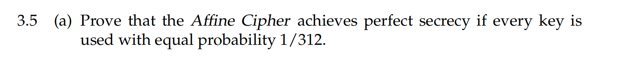

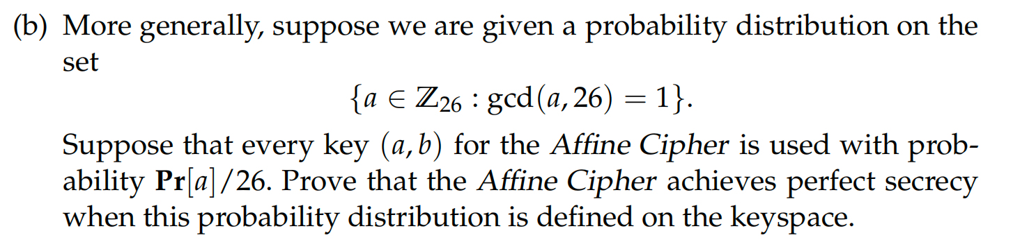

**Answer:**

(a)

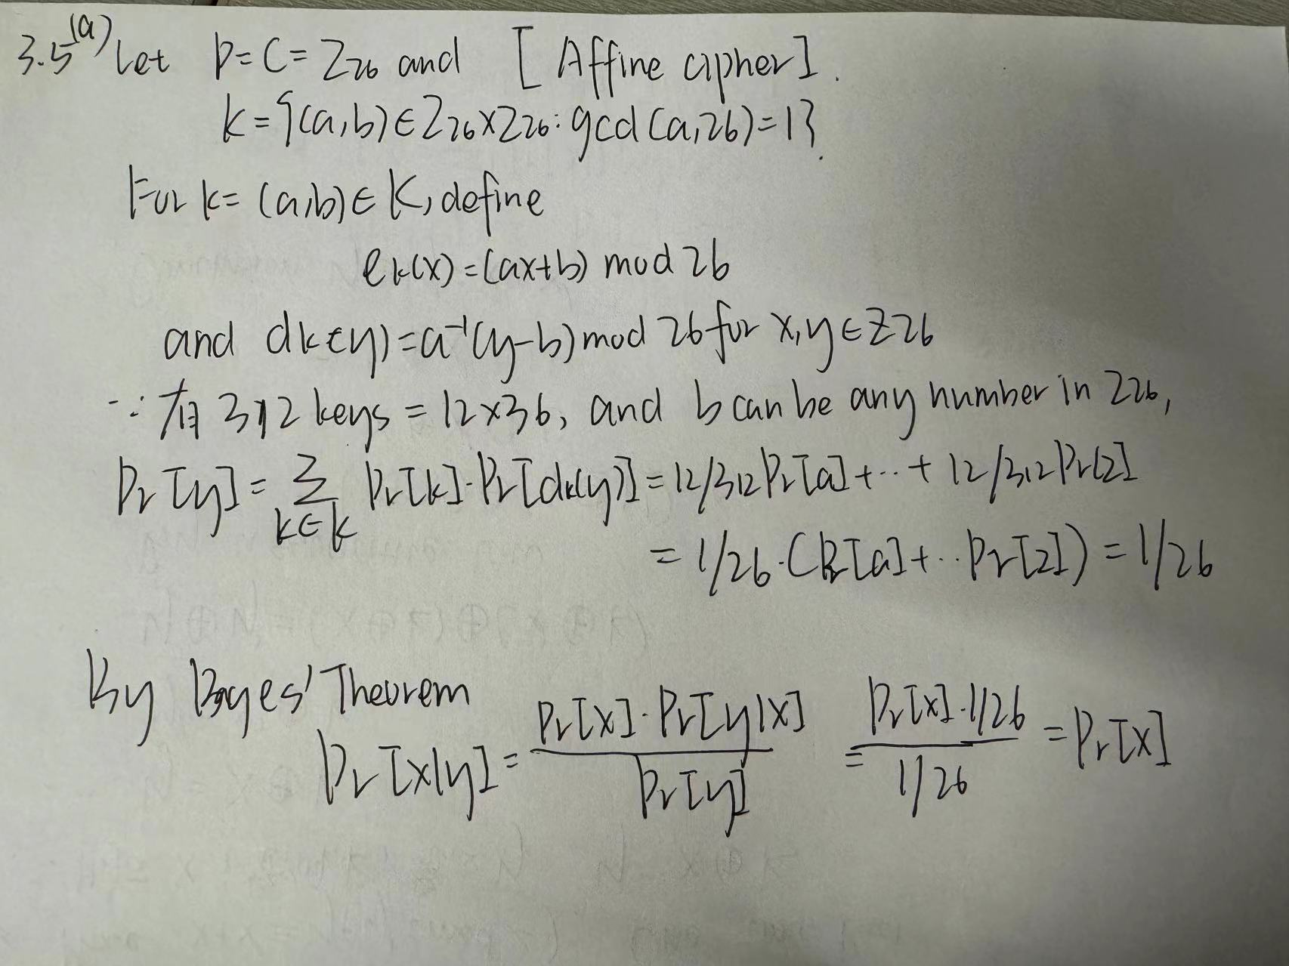

(b)

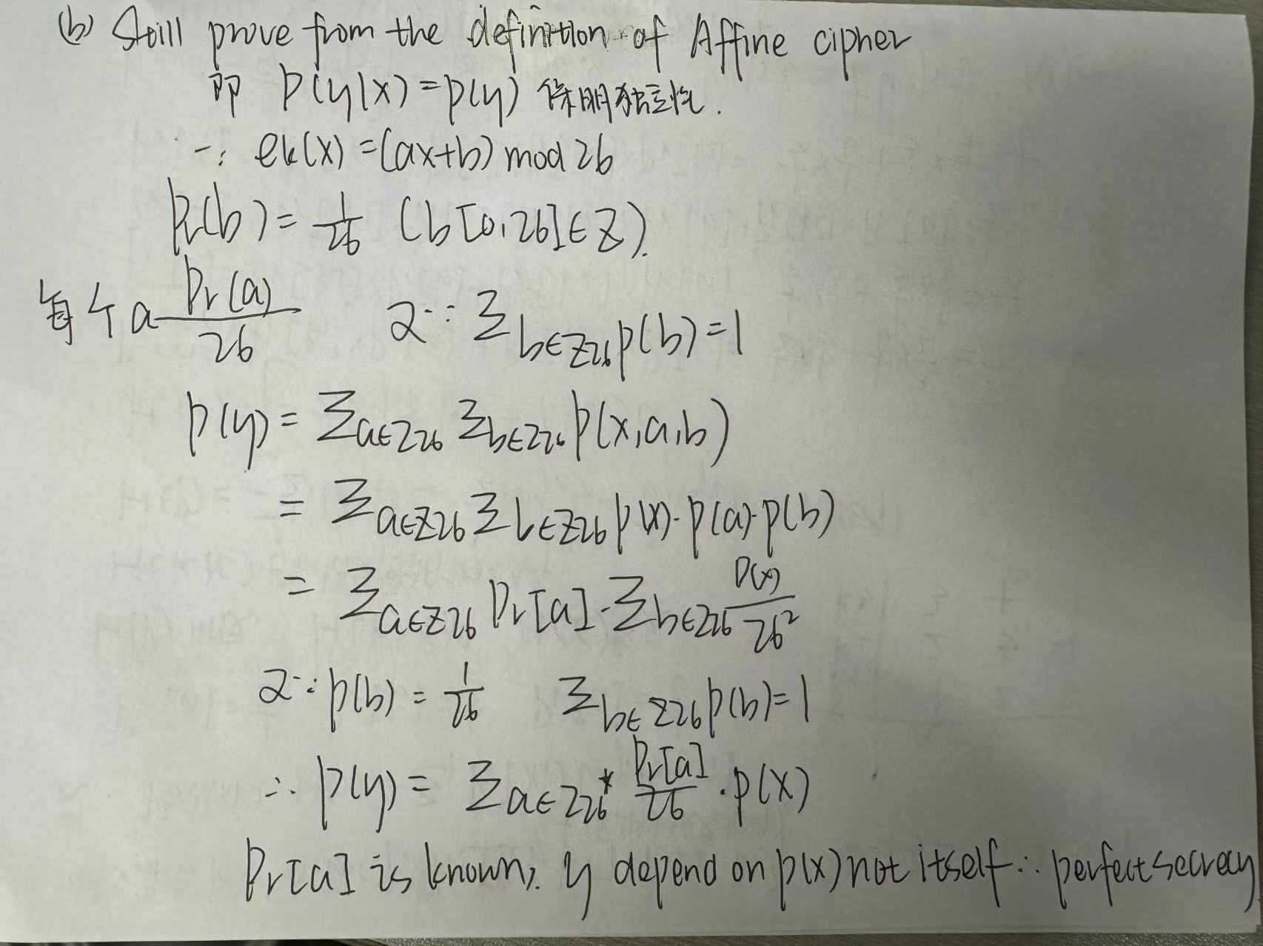

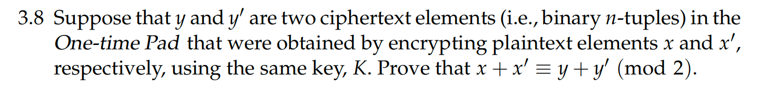

**Answer:**

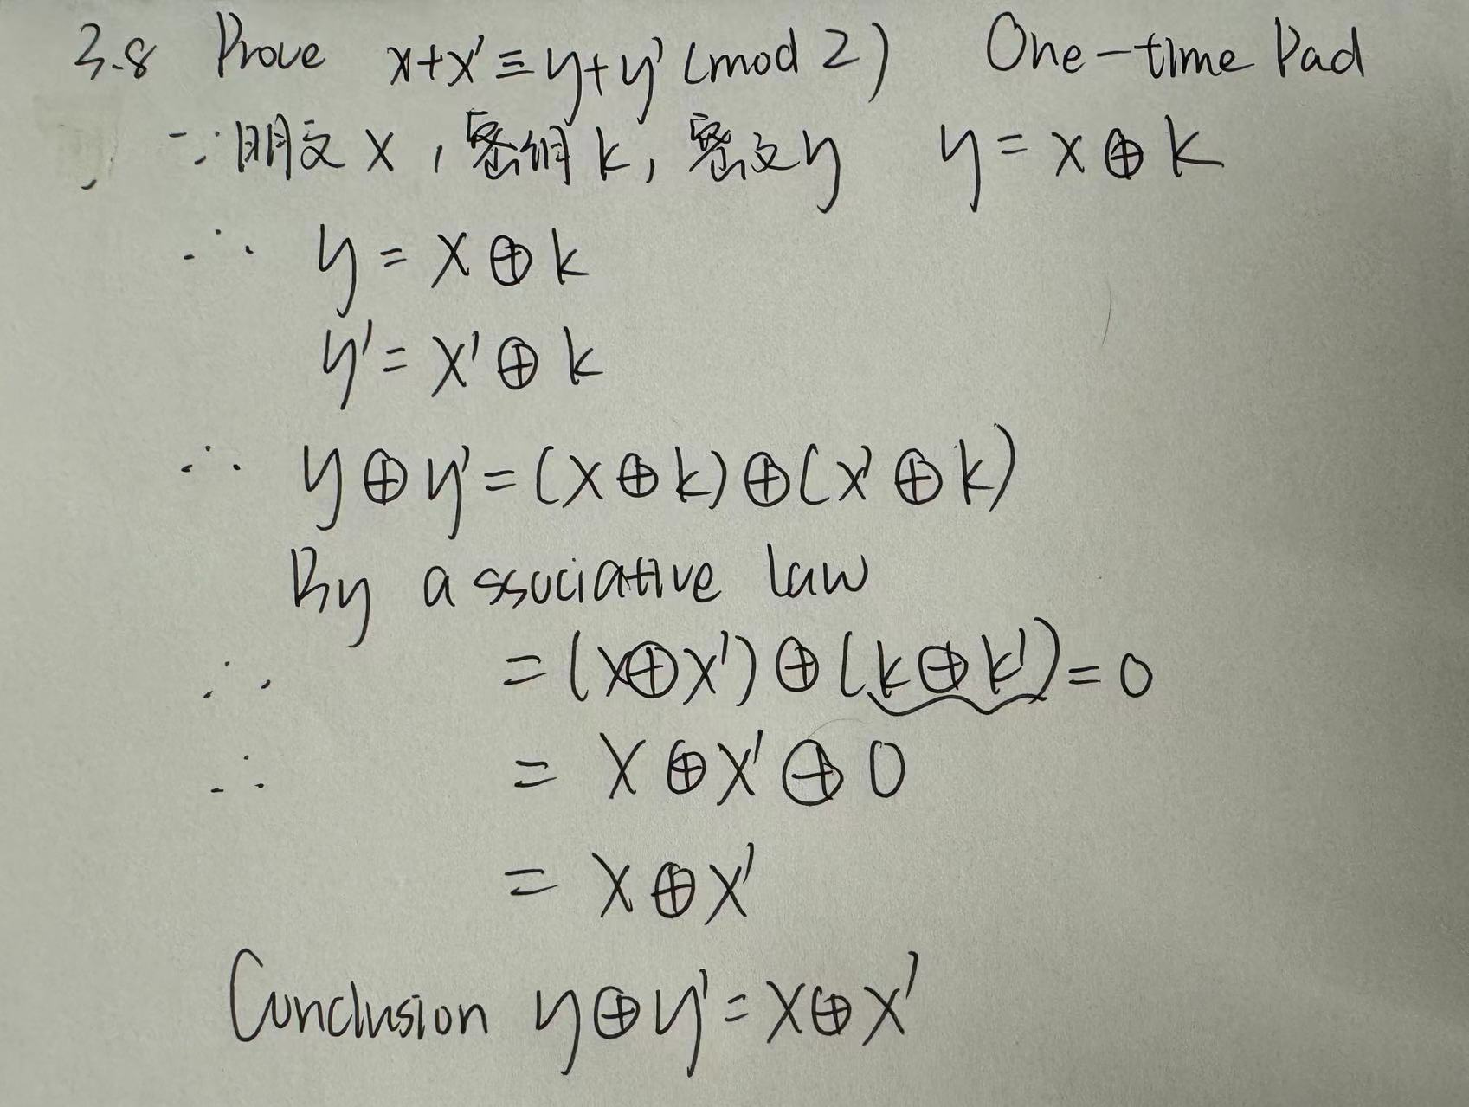



|  |
| --- |
| import numpy as np  # Size of the binary tuple  n = 3  # 生成所有n=3可能的二元组  binary_tuples = np.array([[int(x) for x in format(i, f'0{n}b')] for i in range(2**n)])  # 初始化大小为2^n x 2^n的空加密矩阵  encryption_matrix = np.zeros((2**n, 2**n), dtype=int)  # 构造加密矩阵  # 加密矩阵中的每一项都是表示明文和密钥的二元元组的异或(XOR)  encryption_matrix_output = ""  for i, plaintext in enumerate(binary_tuples):  for j, key in enumerate(binary_tuples):  encryption_matrix[i, j] = int(''.join(str((p ^ k)) for p, k in zip(plaintext, key)), 2)  # 将矩阵行添加到输出字符串中  encryption_matrix_output += " ".join(str(num) for num in encryption_matrix[i, :]) + "\n"  print(encryption_matrix_output)  encryption_matrix |

**Output:**

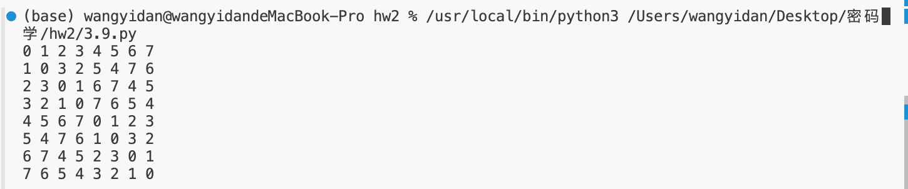

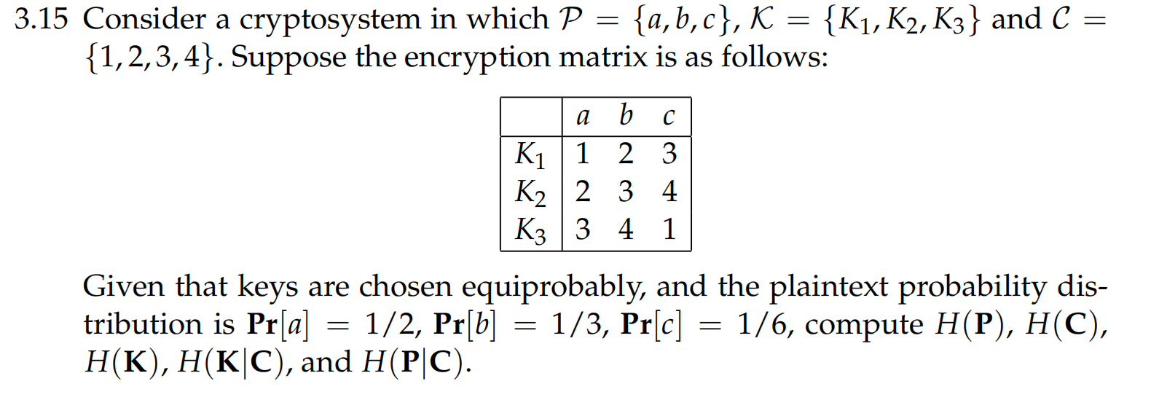

**Answer:**

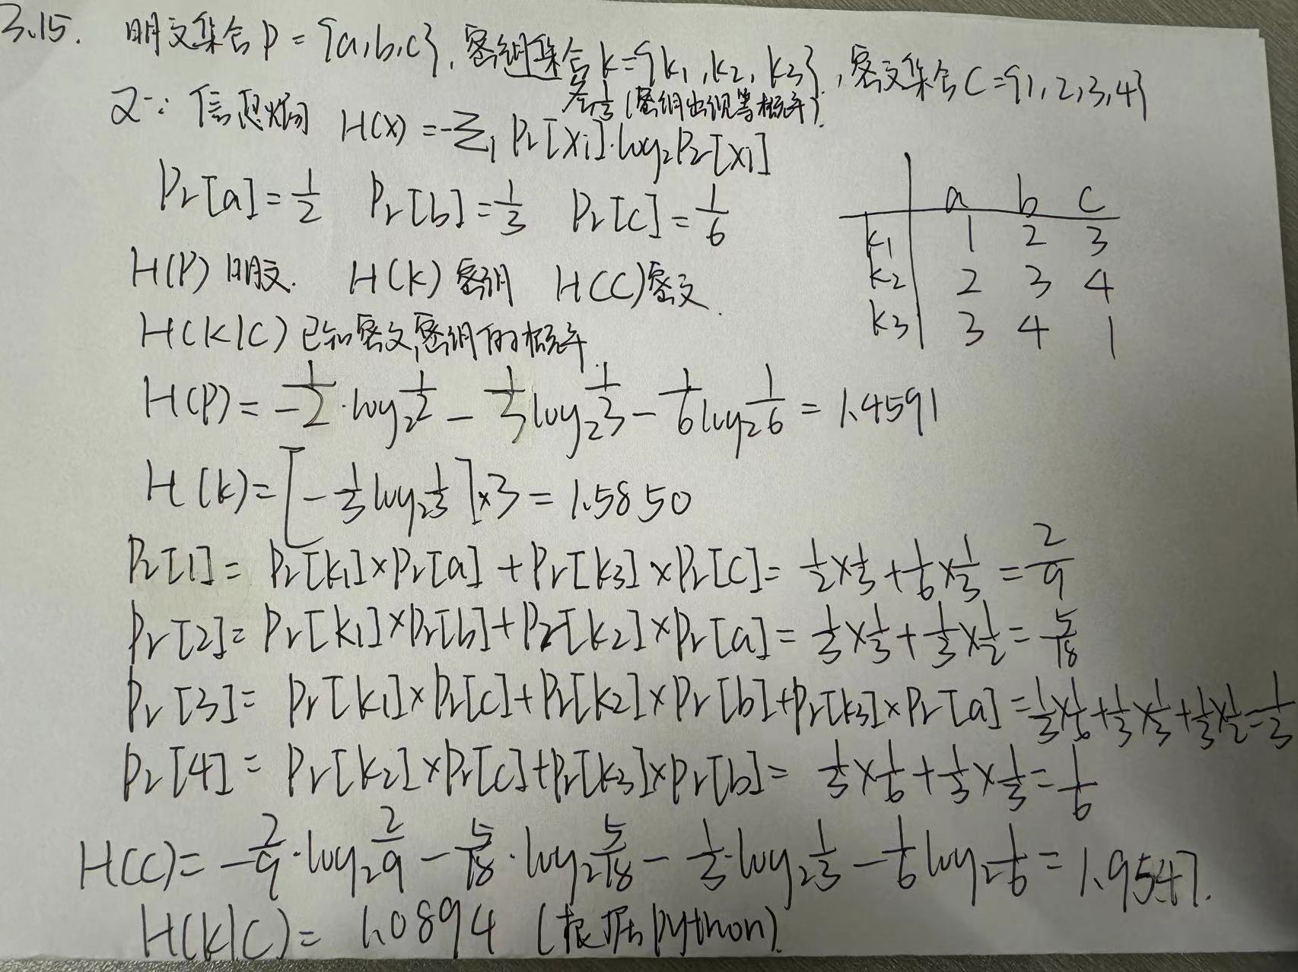

**Python:**

|  |
| --- |
| import numpy as np  # 明文  prob_P = {'a': 1/2, 'b': 1/3, 'c': 1/6}  # 每个密钥的概率相等各位1/3  prob_K = 1/3  # 明文的熵  H_P = -sum(prob * np.log2(prob) for prob in prob_P.values())  # 密钥熵(均匀分布熵的公式)  H_K = -3 * (prob_K * np.log2(prob_K))  # 输出结果  print(H_P, H_K)  # 给定加密矩阵作为一个字典  encryption_matrix = {  'K1': {'a': 1, 'b': 2, 'c': 3},  'K2': {'a': 2, 'b': 3, 'c': 4},  'K3': {'a': 3, 'b': 4, 'c': 1}  }  # 计算C的概率分布  prob_C = {1: 0, 2: 0, 3: 0, 4: 0}  for plaintext, p in prob_P.items():  for key, encrypted_values in encryption_matrix.items():  prob_C[encrypted_values[plaintext]] += p * prob_K  # 密文的熵  H_C = -sum(prob * np.log2(prob) for prob in prob_C.values())  # 用K和C的联合概率分布，从encryption_matrix中推导出来  # 计算条件熵H(K|C)  # 初始化联合概率字典  joint_prob_KC = {k: {1: 0, 2: 0, 3: 0, 4: 0} for k in encryption_matrix}  # 计算每个K和C的联合概率  for key, mappings in encryption_matrix.items():  for plaintext, encrypted_value in mappings.items():  joint_prob_KC[key][encrypted_value] += prob_P[plaintext] * prob_K  # 计算C的边际概率  marginal_prob_C = {c: sum(joint_prob_KC[key][c] for key in joint_prob_KC) for c in prob_C}  # 计算条件熵H(K|C)  H_K_given_C = 0  for key in joint_prob_KC:  for c in joint_prob_KC[key]:  if joint_prob_KC[key][c] > 0:  H_K_given_C -= joint_prob_KC[key][c] * np.log2(joint_prob_KC[key][c] / marginal_prob_C[c])  # 输出结果  print(H_C, H_K_given_C) |

**Output:**



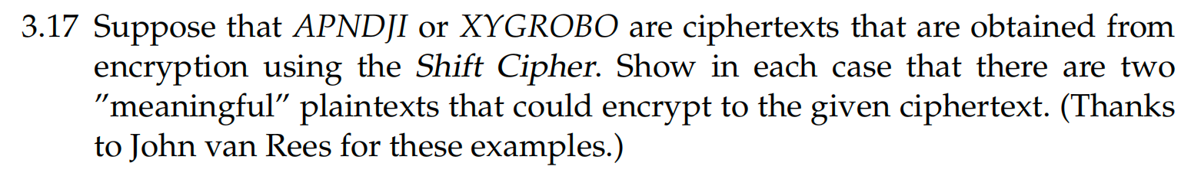

|  |
| --- |
| # 定义一个函数，使用给定的密钥使用移位密码解密密文  def decrypt_shift_cipher(ciphertext, key):  decrypted_text = ""  for char in ciphertext:  if char.isalpha(): # 检查字符是否为字母表  shift = (ord(char) - key - 65) % 26 + 65 # 按键值向后移  decrypted_text += chr(shift)  else:  decrypted_text += char  return decrypted_text  # 给定暗文  ciphertexts = ['APNDJI', 'XYGROBO']  # 因为我们不知道shift/key的值，所以我们尝试从1到25的所有可能性  # 对于一个有效的移位密码，密钥永远不会是0，因为那意味着没有加密，也不会是26，因为它是一个完整的循环。  for ciphertext in ciphertexts:  print(f"Trying decryption for {ciphertext}:")  for key in range(1, 26):  decrypted = decrypt_shift_cipher(ciphertext, key)  print(f"Key {key}: {decrypted}")  print("\n") |

**Output:**

